Add Employers

Functionality: This dialogue allows the user to add an Employer to the Main Org. It allows the user to capture all information necessary for billing, contacting and tracking. The Add-a- Employer Dialogue, in Physia, handles the majority of this. First a review of fields will be discussed and then the action codes will be discussed.

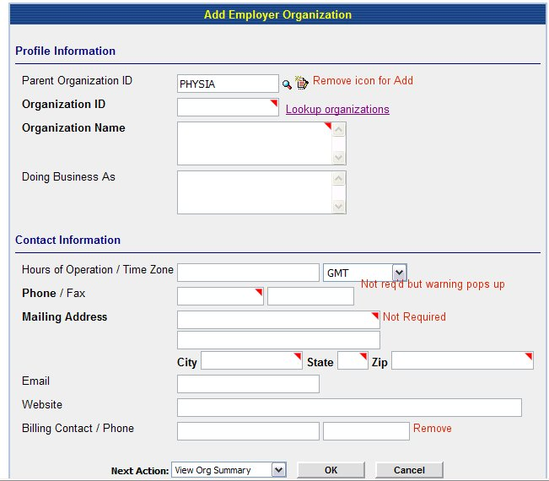
Fig 1a

Remove:
- Remove add button next to Parent Organization ID
- Required markers, in Physia these are red triangles.
- Remove billing contact and phone number.

Edit:

- Look up organization and Look up Parent Org ID should be consistent. Either both should have an icon (like the magnifying glass) or a hyperlink on the word.
- Phone number should not be required but a warning should pop up (see description in Action Code section).

Action Codes

Look up a Parent Org Id: This lookup, whether an icon (magnifying glass or the words are a hyperlink) should take user to a search dialogue which allows the user to search for an existing organization. ***Note the method chosen for lookup should stay consistent throughout the application. **
When the user clicks the symbol or the hyperlink, it should take them to a search engine.

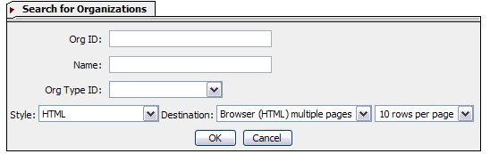

The results should consist of the following:

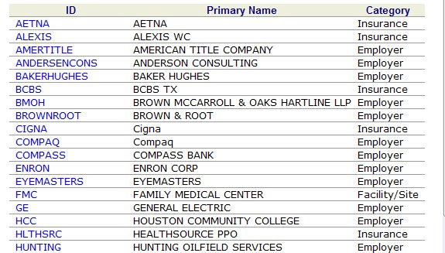

Edit:
- Ensure that results are in alphabetical order by Primary Name.
- Change name of Category column to Type. (This is the name of the field in Add-Dialogue).
- The only items listed in Column 3 (Category) are Associate Providers and Main Org and Employers.
- When user clicks hyperlink, the application should pull that Org Id into the Parent Org Id Field.

Look up an existing Employer ID: This lookup, whether an icon (magnifying glass or the words are a hyperlink) should take user to a search dialogue which allows the user to search for an existing Employer ID. See below. ***Note the method chosen for lookup should stay consistent throughout the application. **
When the user clicks the symbol or the hyperlink, it should take them to a search engine.

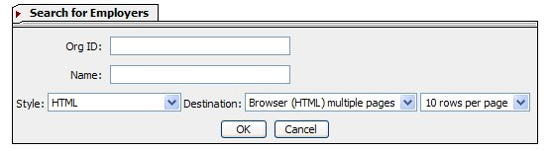

The results should consist of the following:

Fig 1c

Edit:
- Ensure that results are in alphabetical order by Primary Name.
- If an Org is in several Org Types-either all types should be listed under the Org Type column or the Org should have a row for each Org type. (These will appear right next to each other since the Orgs will be listed alphabetically.)

Function

a) If the Org is found in results but not for Employer type, then the user should be able to click the Org ID (the hyperlink) and an additional dialogue should come up:
***If Org ID hyperlinks to Org summary- can it also function to bring up the above dialogue? If not then can the Org name be made a hyperlink to summary page and Org ID made to be the link to above dialogue? *****
Do you want to add [Org_id] to Employer Org type?→Yes→Dialogue for Add-a-Employer comes up with as much information as possible auto filled→User enters any additional information→ User chooses Next Action→User clicks [Ok]→Application performs Next Action.
**See further down for descriptions on next action. **

Or

Do you want to add [Org_id] to Employer Org type?→No→Application takes user back to blank field Add-an-Employer dialogue.

- If employer is not found in the results of the search, the user should be able to close the search results→ application takes user back to add-an-employer dialogue.
- If user clicks Org Id for an org that already is typed, as Employer then the application should pull Pop up a message stating, “ [Org ID] already exists.” In [Employer] org→the user clicks [OK] and the application take the user to a blank Add-an-Employer Dialogue.

Warning on Phone number
If work phone number is left blank the application should show a warning (see below, an example from Physia).



Next Action:

Once the user completes all necessary fields in Add-a-Department Dialogue, they should choose a Next Action (see below)


Fig 1c

Add:
- “Add another Employer”
- “Go to Work List”

Edit:
Change “Go to Directory” to “Go to Search”

Remove:
- Add Insurance Product
- Add Insurance Plan

View Org Summary: Takes user to Organization Summary
Add another Employer: Takes user to blank Add Employer Screen
Go to Search: Takes user to Search engine for orgs
Return to Home: Takes user to their Home Page
Go to Work List: Takes user to Work List

Function:

User Clicks [OK] →Application suggests 3 Org Ids→Application should add an [OK] [Cancel] Button next to suggestions→User chooses Org Id→Clicks [OK]→ Application adds Organization and performs Next Action.

